1. State transition diagram

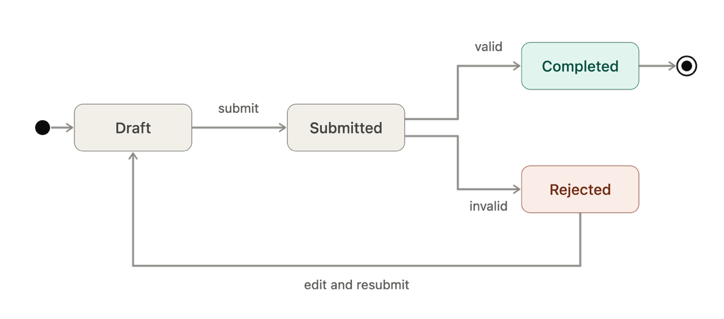

2. State definitions
State | Definition
Draft | The reader is preparing a checkout request and has not submitted it yet.
Submitted | The reader has submitted the checkout request and it is waiting for validation.
Completed | The request passed validation and the checkout was approved. This is the end state.
Rejected | The request failed a validation or business rule. The reader can edit it and resubmit a new checkout request

3. Key transitions
- Start → Draft: reader begins a new checkout request.
- Draft → Submitted: reader submits the request.
- Submitted → Completed: request passes validation and business rules.
- Submitted → Rejected: request fails a validation or business rule.
- Rejected → Draft: reader can edit and resubmit a new checkout request.

